ESP32 Flashing Instructions
Follow these steps to flash your ESP32 with the required binaries and data:

1. Download the Flash Download Tool
Download the ESP32 Flash Download Tool from the [official source](https://www.esp32.com/download/file.php?id=103).

2. Launch the Flash Download Tool
Open the tool and select ESP32 from the dropdown menu.

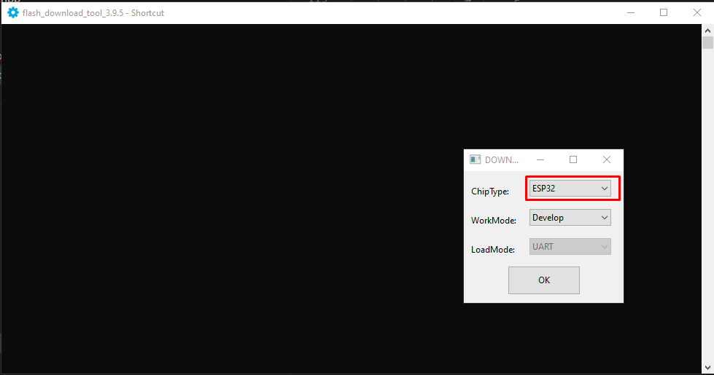3. Configure the Binary
1. Browse and select the binary file to flash: Stefan.ino.merged.bin.
2. Set the flash address to 0x0.

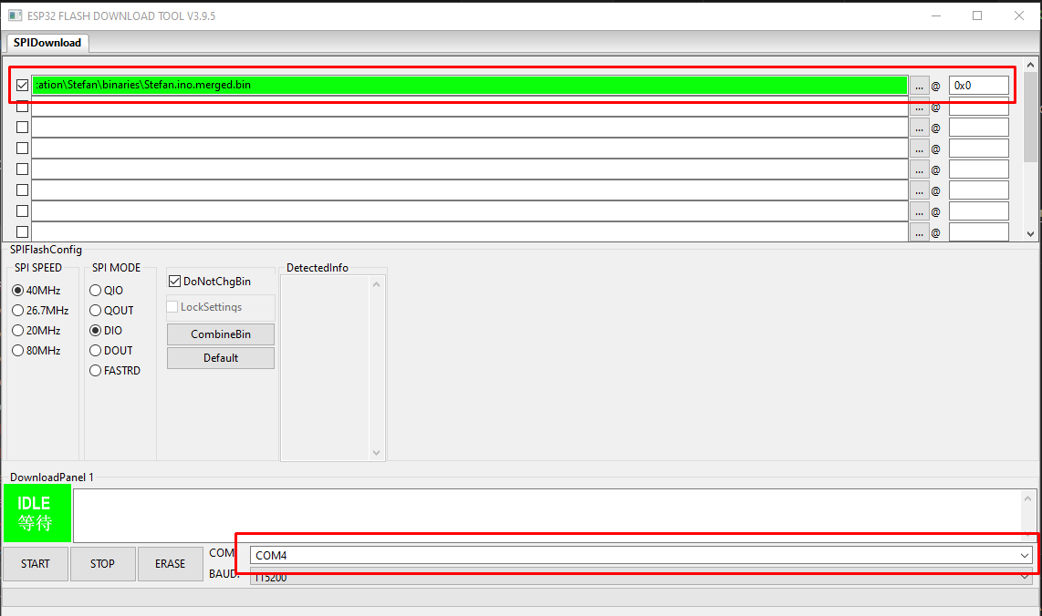4. Flash the Binary
Click Start to begin the flashing process.
---

5. Flash the Data Folder with Arduino IDE
1. Launch Arduino IDE 1.8.
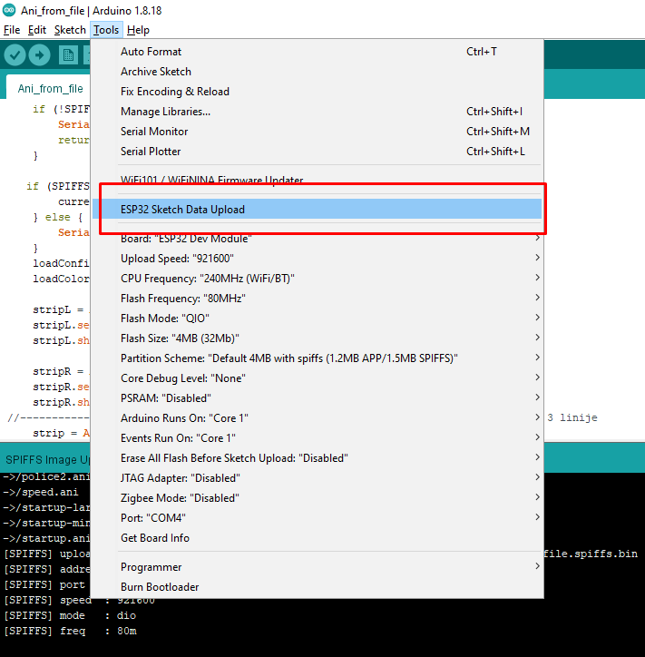2. Select SPIFFS as the partition scheme.
3. Flash the data folder.
